Assignment-3
Q: How to deploy three different files from three different remote repositories on same Apache httpd webserver sequentially?
Steps:
- Create three different repositories and create three different html files on each of them.
- Repo1: 2026Q1 index.html data: This is repo1-Q1 branch
- Repo2: 2026Q2 index.html data: This is repo2-Q2 branch
- Repo3: 2026Q3 index.html data: This is repo3-Q3 branch
- Launch EC2 instance as JM and install Jenkins on it using tomcat (WAR method)
Inside Apache Tomcat, the webapps/ folder is the default location (deployment folder) for applications.
- Create three different Jenkins jobs in which configure repositories Repo1, Repo2 and Repo3 separately.
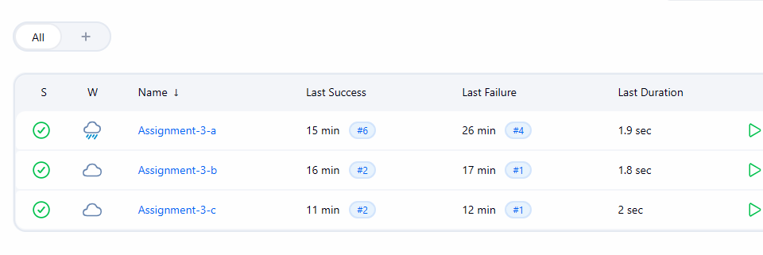
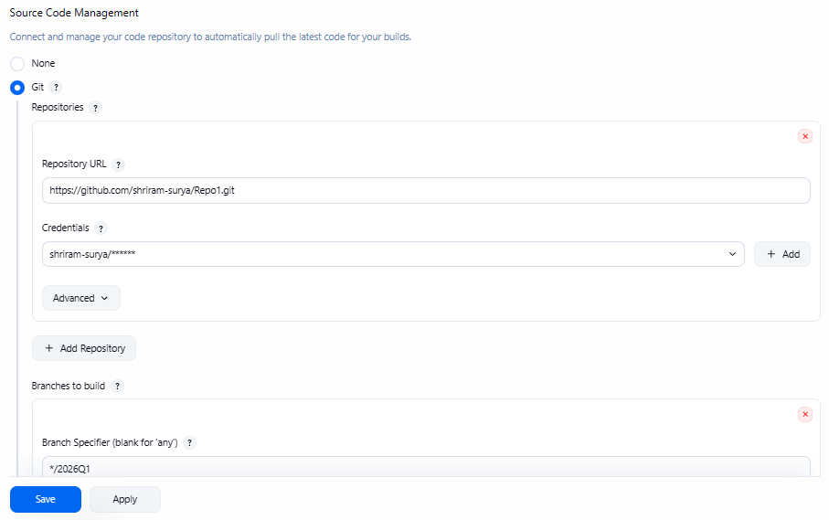
- Write down execute shell script as follows in all three Jenkins jobs:
yum install httpd -y
service httpd start
chkconfig httpd on
cd $WORKSPACE
cp –r * /var/www/html
chmod -R 755 /var/www/html/index.html

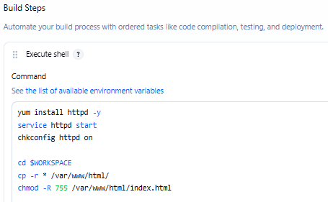

- Now when you can build job- Assignment-1-a then script in index.html of Repo1(2026Q1) will run with public IP of same instance-jenkins-master:
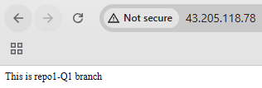
- Now when you can build job- Assignment-2-a then script in index.html of Repo2(2026Q2) will run:
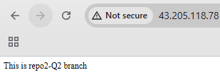

- Now when you can build job- Assignment-3-a then script in index.html of Repo3(2026Q3) will run:
